Numbers Tricks

https://www.facebook.com/events/215612902331135/

CAT favourite. Take your time. Conceptual.

Ps : Jinko samajh na aye wo example se samajh jaynge

[X] is GIF , means [1.3]=1 or [5/2]=2

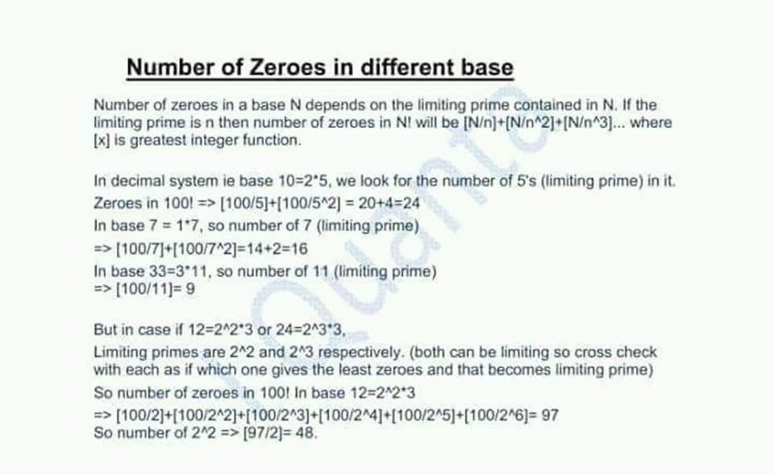

No. of zeroes in 100!

When nothing mentioned it's decimal base. It's our base.   
  
Now all got it correct by dividing 5 continuously.   
  
Why 5 ? Coz the Base 10 = 2*5   
  
5 is the greater prime hence the value it will give on dividing will be lesser and hence this value will be the answer. ( 2 obviously will give larger value so we will ignore it )  
  
[100/5]+[100/5^2] = 20+4=24.

Q. Number of zeroes in 124! In Base 21 is ?

Oa : 19  
  
Solution : Base = 21=3*7   
  
So 7 will be the limiting prime clearly  
  
[124/7]+[124/7^2]= 17+2=19

Q. Number of zeroes in 100! in base 24 is ?

24 = 2^3 * 3 = 8 * 3 (limiting prime becomes 8)

100/8 + 100/8^2 = 12 + 1 = 13

24= 2^3*3  
  
By checking with both primes  
Which ever gives lesser 0 will be limiting prime.  
  
Number of 2's in 100 is [100/2]+[100/4]...[100/64] = 97   
  
So Number of 2^3 will be [97/3] = 32 .  
  
Number of 3's   
[100/3]+[100/9]+[100/27]+[100/81]= 48  
  
32 is lesser so the answer is 32. https://static.xx.fbcdn.net/images/emoji.php/v9/e40/1/16/LIKE.png(Y)

Q. Number of zeroes in 1000! In base 10. ( Cat 2014)

[1000/5]+[1000/25]+[1000/125]+[1000/625]=200+40+8+1=249

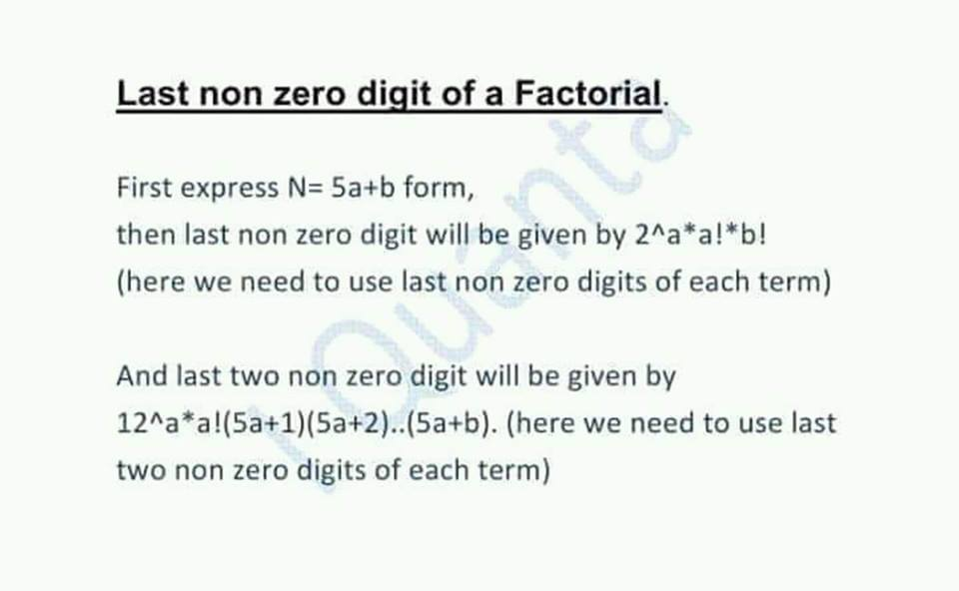

Q. Last non zero digit of 24! is ?

OA : 6   
  
Solution : 24= 5a+b=5*4+4  
  
a=4, b=4  
  
Last non zero digit = 2^4*4!4! =   
  
Keep multiplying last non zero digits of above term : =>   
  
6*4*4 = 6 .

Q. Last non zero digit of 32! is ?

32 = 5x6 + 2   
  
So 2^6 * 6! * 2!   
  
=> 4 * 2 *2 = 6

(consider 6! ka non-zero)

always consider non-zero only.

Q. Last non zero digit of 43!

43 = 5x8 + 3   
  
2^8 * 8! *3!   
  
=> 6 * 2 *6 = 2

Q. Last two non zero digits of 21! Is ?

consider only last 2 digits.. even during each multiplication

21 = 5*4 + 1

a = 4 b =1

12^4 * 4! * 21=

= 44

Oa: 44  
  
Solution : As 21 = 5*4+1  
  
12^4*4!*21 = keep multiplying last two digits of each term only  
  
12^4 ka last two digit :   
  
144^2 = 44^2=(50-6)^2 same as 6^2 = 36   
  
So 36*24*21 =:44  
  
You get 44,   
  
Let me tell you 99.9% of the janta doesnt know this formula.

Remember it !! Kaam ki cheez. Also include 76 in the list

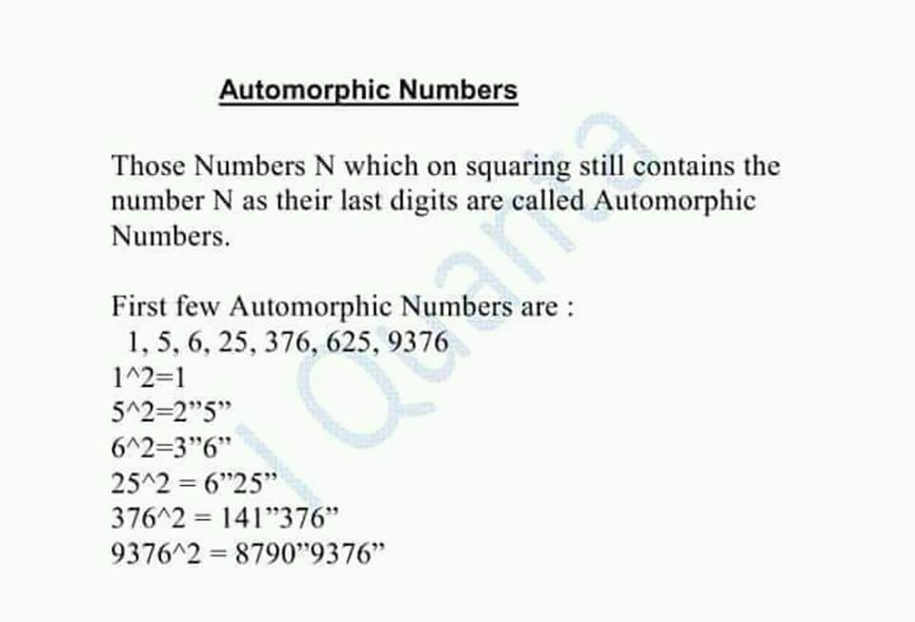

Q) If a 3 digit number on squaring still contains the number as it's last digits, what is the sum of its digits ?

number will be 376/625

sum will be 16/13

Oa : CBD   
  
16 or 13   
  
376 and 625 both satisfies.   
  
● this was a Mock cat question last year and almost all answered it wrong or left it except few iQuanta students. https://static.xx.fbcdn.net/images/emoji.php/v9/fce/1/16/1f600.png

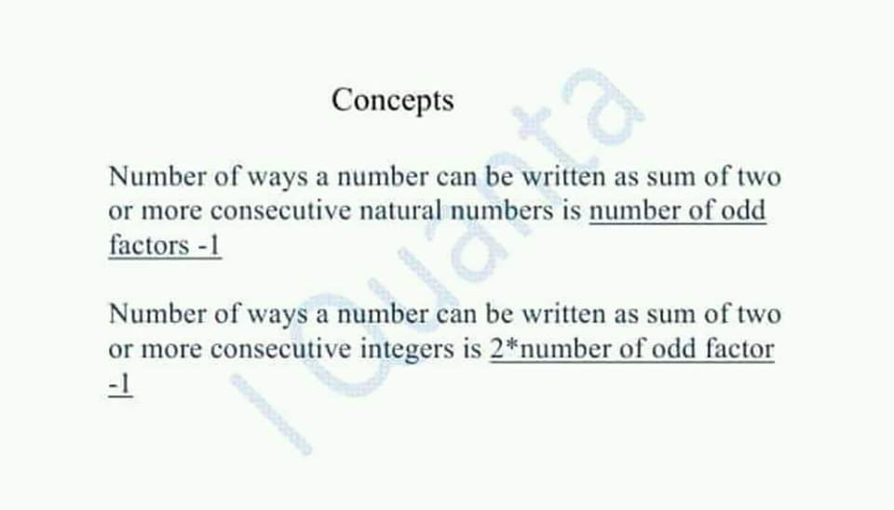

logic   
  
sum of any 2 consecutuve number is always odd   
  
as even + odd = odd   
  
so it depends on its odd number of factors

Q. How many ways 540 can be written as sum of two or more consecutive **natural numbers** ?

Oa : 7   
  
Number of odd factors of 540 = 8   
  
So 8-1 = 7.   
  
Note : the Common method is very uncommon. And takes 5 mins.   
  
Just remember it depends upon odd factors.   
  
Why odd numbers? Coz sum of two consecutive number Is always odd.

Q. How many ways 720 can be written as sum of two or more consecutive **integers** ?

720 = 2^4 * 3^2 * 5

odd factors = 3*2 = 6

ans = 2*6 - 1 =11 (because integers)

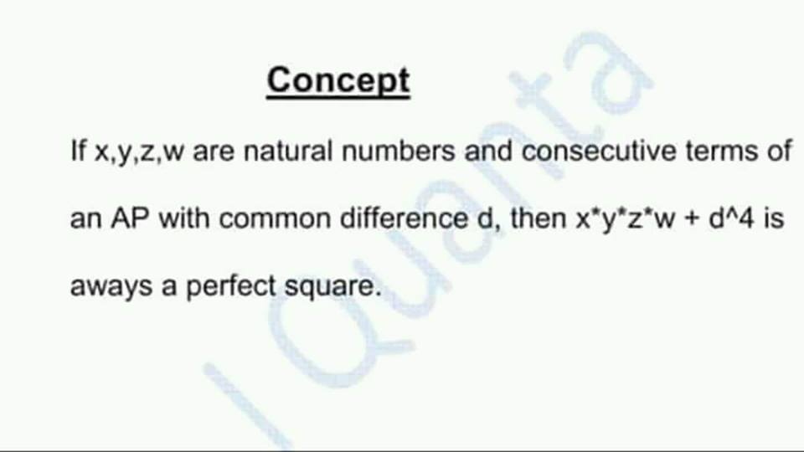

Q. Smallest number to be added to 17*20*23*26 such that it becomes a perfect square is ?

17,20,23,26 in ap

we know x*y*z*w + d^4 makes it perfect square.

so add d^4 ie 3^4 = 81.

17*20*23*26 so common difference 3 then  
  
17*20*23*26+3^4 = perfect square   
  
and 3^4 = 81 so its the least number

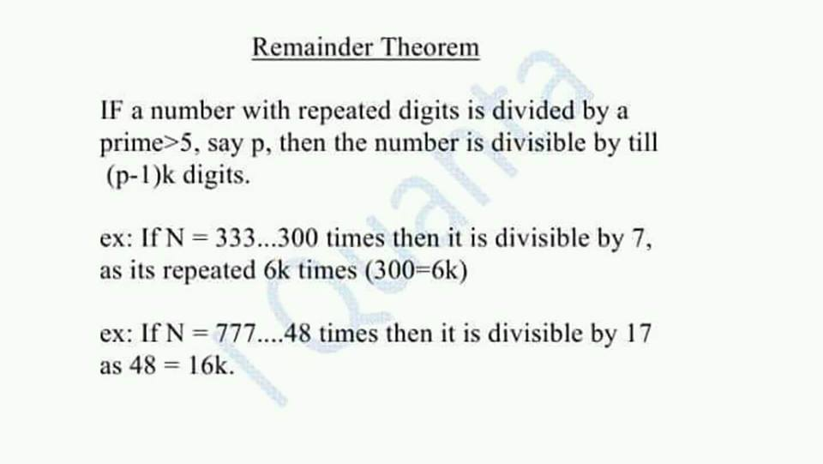

Q. 666....80 digits mod 17

 E(17)= 16  
  
80 mod 16 = 0   
  
So divisible

Q. 777... 56 digits mod 19 = ?

Oa:1  
  
E(19) =18,  
  
So 54 digits tak remainder 0  
  
56 mod 18 =2   
  
So check last two digits ,   
  
77 mod 19 = 1 ●ANS  
  
●Remember : In a^n type ,   
  
we do ... n mod euler   
  
and in aa...... n times   
  
n mod euler

Q. 55555... 302 digits mod 21 =?

e(21) = 12

302 mod 12 = 2

so last 2 digits left

hence 55 mod 21 = 13

Method 2   
  
E(21)= 12   
  
302 mod 12 = 2   
  
now 55 mod 21 = 13

General method  
  
21 = 3*7  
  
N mod 3 = 5*302 mod 3 = 1 . ( sum of digits )  
  
N mod 7 =  
  
We know E(7)=6   
  
So upto 300 digits it will be divisible by 7  
  
Left with 55 mod 7 = 6.   
  
So 3a+1 = 7b+ 6   
  
a=4, b=1 satisfies to give   
  
R = 13

Euler gives the cyclicity whether power or repeating digits

Cyclicity about divisiblity.

So euler gives till that power or repition, its divisible

Then whatever left we find manually.

Agreed ?